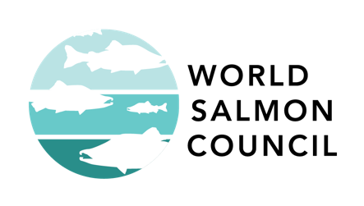
The Fish Friendly Game
Used with permission from City of Portland Bureau of Environmental Services

Level: All ages

Time: 30 minutes

Objectives:
- Learn about the salmon life cycle
- Learn about human impacts to salmon habitat like pollution and land-use practices
- Learn about predator/prey impacts to salmon
- Have fun!

Materials:
- 1 – 6-sided Die
- 4 game pieces (e.g. coins)
- Pencil and paper
- Printed gameboard

Directions:
- Each player starts out with 1,000 fish.
- Players alternate rolling one 6 sided die.
- If you land on a space that tells you to move forward/backward spaces, follow those instructions once and your turn is complete.
- If you run out of fish before you reach the end, you can start over at the beginning with 1,000 eggs and try again.
- Winners reach the finish line with at least 100 fish left.

After the game:

Use the following writing prompts to develop the concepts from the game:

- What challenges did you encounter while playing The Fish Friendly Game?

- Make a list of all the negative and positive encounters you had while playing the game.

- Propose 5 actions you could do as a family or a citizen to decrease the number of challenges that salmon encounter in their habitat.

- Make a power point, children’s book, comic, rap, song, poem about Salmon to share with the class.

