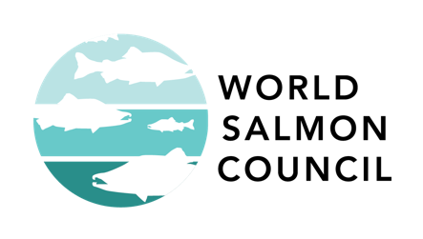
Salmon River :
What Makes a Salmon River?

- This activity is based on a 360° panorama virtual tour – Go to the tour

Tip: Visit all 4 locations in the tour to find all the answers.
Tip: Turn on sounds with the speaker icon in the top left corner.
More tips:
    - Click and drag or use arrow keys to look around
    - Click to make buttons appear or disappear
    - Scroll to zoom

- Find the 6 objects that describe a healthy riparian zone and fill in the table.
Hint: Look for the little “i” information hotspots: 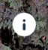

Object | What’s the object? | How does a healthy riparian zone function like this object? | What benefit is provided to salmon?
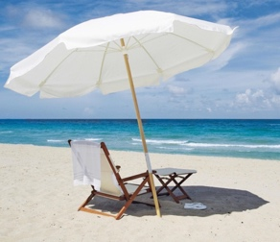
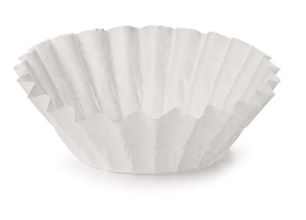
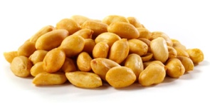
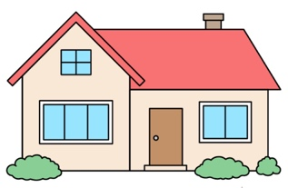
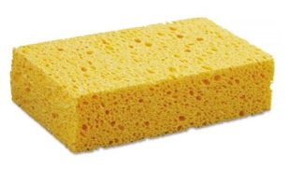
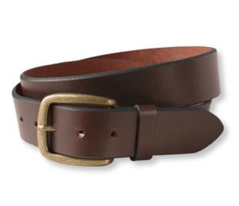

- What are three possible uses for the Western Red Cedar tree?

___________________________________________________________________

__________________________________________________________________

__________________________________________________________________

- What are the 4 C’s that describe water that salmon require? The first is done for you. Fill in the remaining table.

 | C Words | How does a healthy riparian zone contribute to this water quality?
1 | Cold | The riparian zone provides shade (beach umbrella). It also slows down water from entering river (sponge).
2 | C
3 | C
4 | C

- What does “marine-derived” mean?

___________________________________________________________________

___________________________________________________________________

- The relationship between the riparian zone and salmon is one of reciprocity. What do the salmon give to the forest?

___________________________________________________________________

___________________________________________________________________

- Did you find any salmon? If so, how many? _______________________________

- If you could only see this river from the air (“Raven’s View”), could you make a guess about how healthy it might be? What clues do you see?

___________________________________________________________________

___________________________________________________________________

___________________________________________________________________

- What would an unhealthy riparian zone look like? Describe it in 2-3 sentences.

___________________________________________________________________

___________________________________________________________________

___________________________________________________________________

- What’s one easy thing people can do to create a healthier riparian zone for salmon?

____________________________________________________________________

Bonus
- Can you name any of the birds you heard?

________________________________________________________________________

- What’s the Oregon State flower?

________________________________________________________________________

