Benthic Macroinvertebrates

How to Use this Outline: This outline was originally made to accompany a program bin with education conducted by a classroom teacher or environmental educator. In uncertain times we become flexible and adaptable; insert at-home lesson plans. Starting with the pre-activities you (the amazing at-home-educator) can get some background on the topic and learn some helpful websites for teaching the subject. The procedure section is designed to be hands-on and interactive and student driven. The post-activities are a fun way to insert art, crafts, snacks and other resources to review content and have fun with the subject matter. Please reach out if you have any concerns or issues jenny.ammon@marionswcd.net
Level: 3 - 12 grades
Time: 60 minutes
Objectives:
- Students will understand the importance and roles of macroinvertebrates in the aquatic ecosystem by:
  - Identifying the macroinvertebrates pictured in the lesson plan
  - Counting and recording invertebrates from each habitat using StreamWebs data form.
  - Analyzing the data to determine the health of the stream.
Materials:
- Macroinvertebrate identification keys/field guides (from the Xerces Society)
Pre-Activities:
Adult and Student should visit this link together to build knowledge of macroinvertebrates prior to the procedure below.
World Salmon Council curriculum https://worldsalmoncouncil.org/wp-content/uploads/2015/08/Field-Study-Macroinvertebrate-Identification_Full-Resource-Guide.pdf
Procedure:
Indoor Experience would be an abbreviated class concentrating on the identification, classification, and determination of the health of the stream utilizing caught macro invertebrates.
- Use the field guides to help with identification of the macroinvertebrates pictured below. The field guide link will give information on habitat, behavior, feeding, and tolerance values (sensitive, moderate, tolerant)
- Have the students use the field guide to label the pictures with the correct invertebrate name and its corresponding tolerance value. 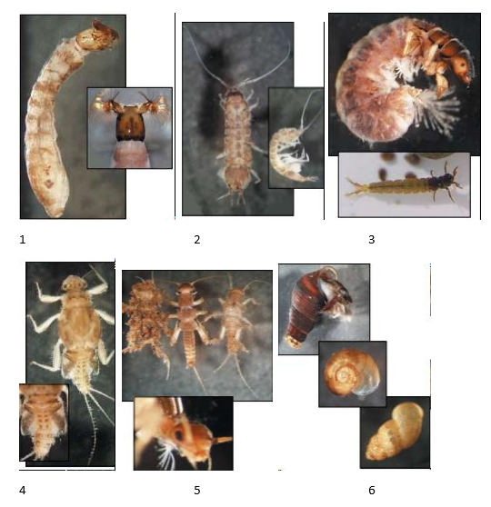

- Name:___________________________ Tolerance Value:_______________________
- Name:___________________________ Tolerance Value:_______________________
- Name:___________________________ Tolerance Value:_______________________
- Name:___________________________ Tolerance Value:_______________________
- Name:___________________________ Tolerance Value:_______________________
- Name:___________________________ Tolerance Value:_______________________
How would you rate the body of water these macroinvertebrates were living in based upon the macro samples and their tolerance values? Circle one.
- High quality stream
- Medium quality stream
- Low quality stream
Post-Activities & Resources:
- Build a bug pages 319-322 https://www.dfw.state.or.us/fish/STEP/docs/SS9_AquaticOrganisms.pdf

